Matthew Roesch

Probability and Applied Statistics

When starting this journey to use our graph tools, first I had to do what we do everytime we jump into something new, and learn the very basics of Octave. Now for this I found a video titled “Octave Tutorial for Absolute Beginners: Learn Octave in 1hr and 30 min” As I went through, most of these are things I can easily pick up on, as there are similar rules to java’s arithmetic and variable creation. To start, the video just goes over basic variable creation and arithmetic operations.

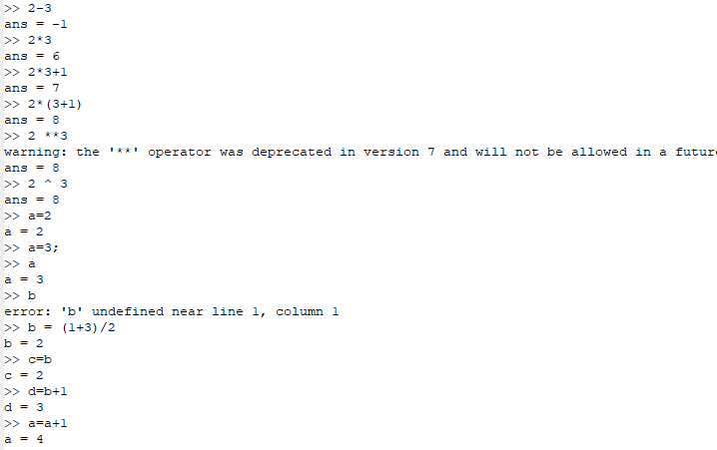

The next big step that is covered is vectors. Essentially, the java equivalent of arrays are these vectors. Vectors are split into row vectors and column vectors. These will clearly come in handy when working with matrices. Again, the commands to create vectors are similar to arrays, so this is easy to pick up for me.

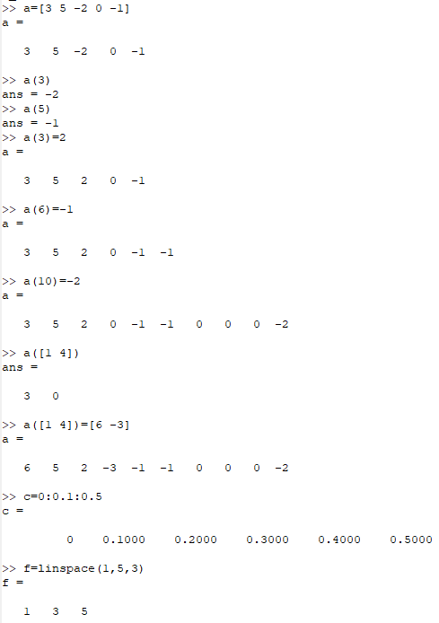

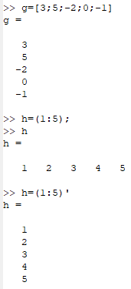

Now we get into matrices. Firstly we obviously need to start with how to create them. This is quite intuitive, as I am seeing this pattern in octaves syntax. Then we start to work with matrix operations, including addition, subtraction, scalar multiplication, and matrix multiplication. Most of this is very simple, especially since in another one of my classes I worked with matrices quite a bit this semester. The only problems that may arise are from not following the rules for matrices operations, like trying to multiply matrices of different sizes without the common length/height to multiply them.

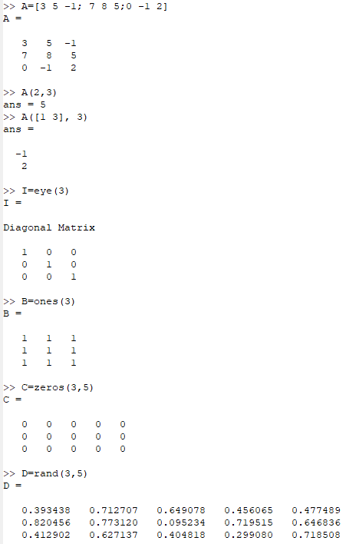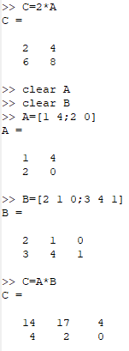

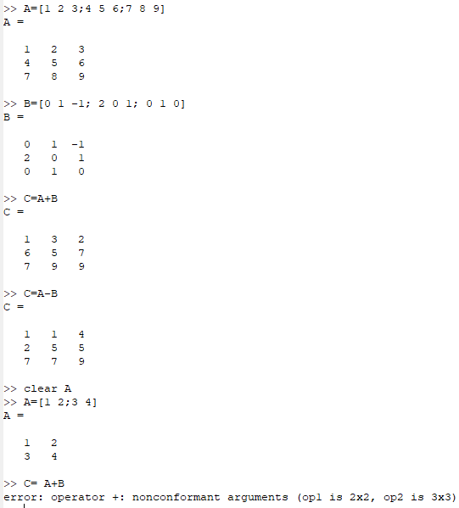

After testing the matrix operations, the tutorial I am following covers plotting data. This is going to be very useful in my mission to graph, salt, and smooth data. Alongside this, I found out how to write both scripts and functions.

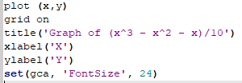

After this, I set off to write functions that could plot, salt, and smooth data. Then those functions would plot the data into a graph.